Introduction

Geocadabra can be downloaded from the website (www.geocadabra.nl) and can be launched from the Windows menu or the icon on the desktop after installation. Needless to say, not all functions are available in this demo version. However, by going through this booklet you will get a fair idea of the possibilities since the demo supports all given examples.

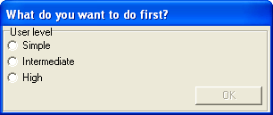
When launched for the first time, Geocadabra allows you a choice between various levels of difficulty. Should you decide to work on a lower level exercise, the remaining, more difficult levels will not be shown in the menus and you will be only presented with those exercises that are suitable for your level.

This booklet will mainly discuss the basic starting level.

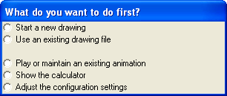
There are various ways to start:
- With a new drawing.
After choosing a basic object, you are free to manipulate it any way you want.
- With a drawing from the system.
A drawing can be saved and re-opened at any time.
- With playing an animation.
- With a calculator.
This is a special calculator that can calculate fractions and roots.
- With adjusting the configuration. The configuration screen allows you to determine exactly how Geocadabra should behave. On the website is a download centre with a text file (the user interface) that gives a more detailed description of the configuration screen.

Geocadabra features a built in camera that can be switched on at any given moment. The camera will record all actions on screen and allows for a pupil to demonstrate in class how a complicated drawing was constructed or how he/she dealt with a certain problem. The recorded approach to a problem and the solution can of course be sent to the teacher by e-mail!

The construction box
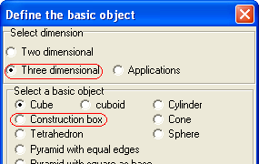
We are going to practise using different views. First, choose file, new drawing, three dimensional, and construction box.

An empty grid (4 by 4) will appear as well as a control screen.

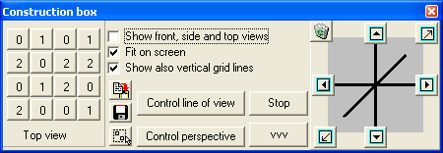
This screen indicates how many blocks have been piled on the grid.

Clicking a square in the control screen will add a block to the grid. Use your right mouse button to remove a block. This program helps you build block-models and its main aim is to help you draw a variety of views.

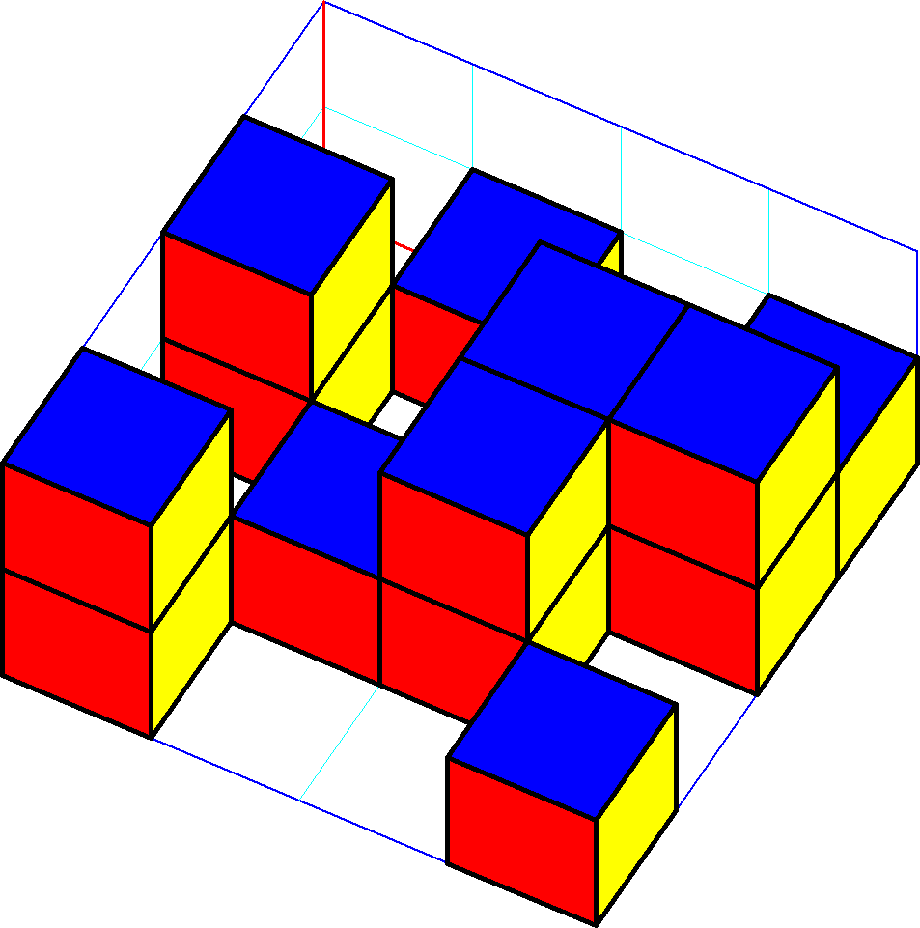
(This demo only allows you to build small towers of up to two blocks high. The licensed version also allows you to work in realistic perspective and with random heights.)

Click on [control line of view].
Place the mouse over the drawing and drag it while holding the left mouse button. The viewpoint of the drawing changes and now you can see what the front, side and top view look like.

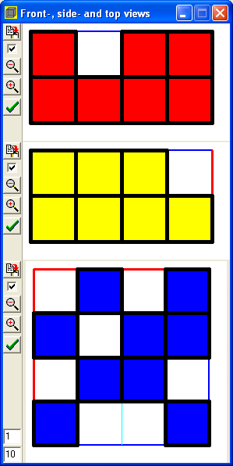
After you have drawn these views, you can look up the answer and see whether your answer was correct. This view screen allows you to temporarily render certain views invisible so that you can check one view without already seeing the others.

There is also the option of including measure tools used for measuring lengths, angles and surfaces but we will discuss that later.

Plane geometry
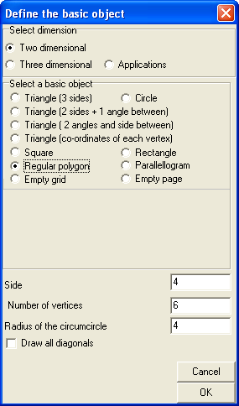
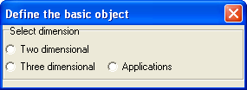
You have a choice between working with two-dimensional or three-dimensional figures. (The third possibility will not be discussed in this booklet.)

We will be working with two-dimensional figures.
Choose the option regular polygon. Check the same boxes as in the screen alongside and click [OK].
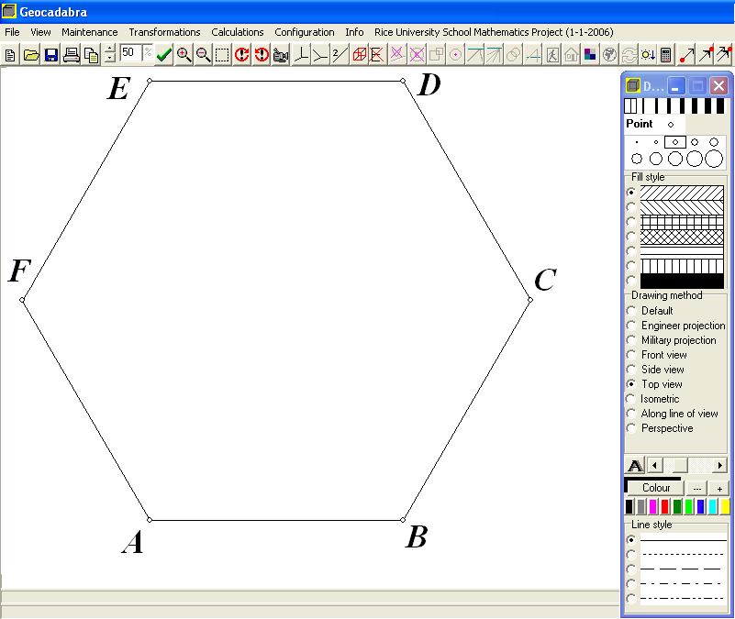
The polygon will appear on your screen.

To the right of the drawing a toolbar will appear. This will help you to determine:
- The thickness of the lines
- For future points to be open or closed
- The radius of future points
- The fill style
- The drawing method
- The drawing colour
- The line style
This bar is where you determine how future details are drawn.

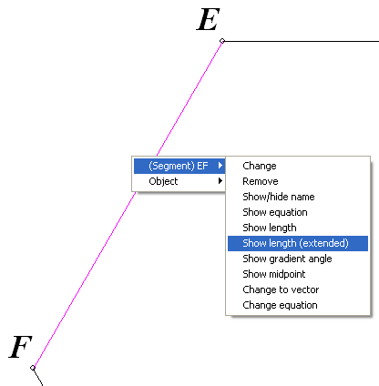
You can also use it to change existing features. This is how it works:
Choose the colour red and a thicker line.
Now right-click on one of the line segments in the drawing.
A menu will appear that allows you to choose an action
Choose ‘change’ and the line segment will become red and thicker.

Remember:
After having chosen the desired configuration in the toolbar, you can change the way a line or point was drawn by pressing the right mouse button and selecting the appropriate changes in the menu that will appear.

Once Geocadabra has been authorised, the option maintenance in the upper most toolbar will also become available. Pressing this button will result in an extensive menu that lists all the available commands for points, lines, angles, circles, surfaces, functions and many more. Unfortunately, this option is not available in this demo.

The toolbar above the drawing consists of a lot of buttons and we will now continue to explain their various functions.
The ‘drag button’. Click it and place the mouse over vertex (angular point) A of the polygon. Now move the mouse about while pressing the left mouse button. Point A will move along with the cursor and the drawing will change but it still remains a regular polygon.

One point animation. Click it and put the mouse over vertex A of the polygon. Move the mouse again while pressing the left mouse button and a spring will appear. As soon as you let go of the mouse button vertex A will be launched and thus changing the drawing. However, it still is a polygon.

This is what we call dynamic geometry: even though you move one point, all characteristics of the drawing remain unchanged. In this case we still have the drawing of a regular polygon.
Please note that only vertex A can be moved. This is because vertex A is a so-called independent vertex and all the other points are dependent, they are dependent of A. An independent vertex can be recognised by the text “this point?” that will appear when the cursor is close to it (of course, you will need to have pressed the “one point animation button” first!). Dependent vertices do not get that text.
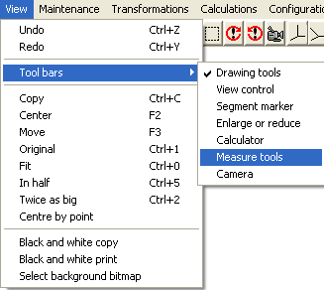
We are going to take a look at the menu’s hidden in the upper most toolbar.
Click view and choose toolbars, measure tools.

A box will appear in which you can activate several gauges:
- Length gauge: use this to measure the distance between two points;
- Gonio gauge: drag vertices of gauge to measure angles;
- Area gauge: use this to measure the area of, for instance, triangles and quadrangles.

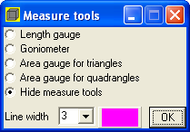
Choose a measure tool and drag the vertices of the gauge to those of the polygon and determine distances and areas.

Why not try the following:
- Change the length of the sides of the polygon to about 4;
- Measure the angle CAE;
- Determine the area of the polygon.

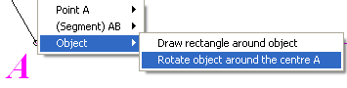
For those of you who like a twist; why not click on a vertex with the right mouse button? In the menu that will appear, click “Object” and “Rotate object around the centre…”

Investigating a section

The program allows for many different ways to generate an intersection of a three-dimensional figure. One of them is supported by this demo and it can be accessed through the quick access bar in the top centre of the screen.

After having clicked on the far right button you can click on three points in the figure. Mind you, these points do not necessarily have to be vertices, you can click anywhere on one of the line segments and create a new point.
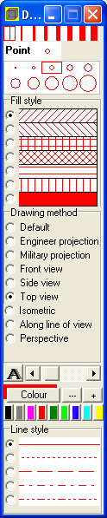
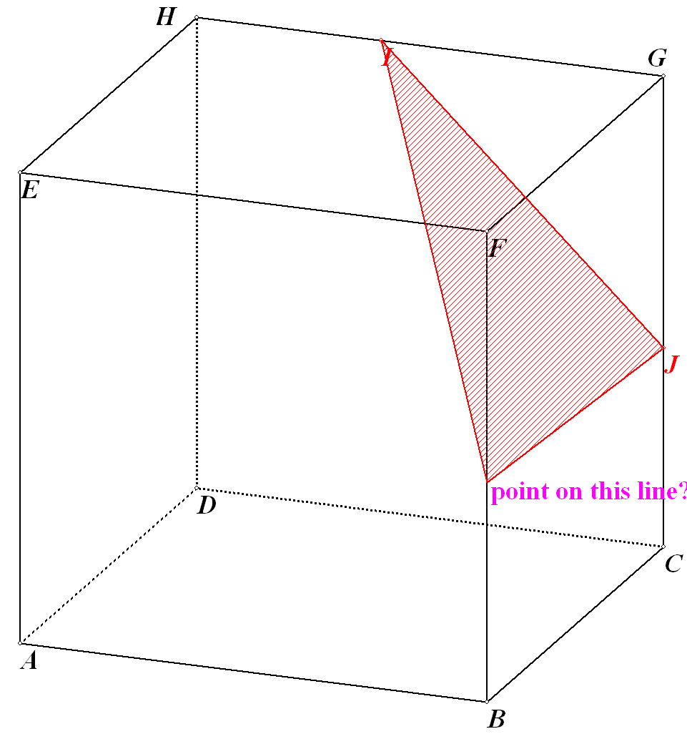
You should first determine the colour and the brush style of the fill style. You can do so by accessing the tool bar on the right side of your screen.

After the third point has been determined, the entire section will be drawn.

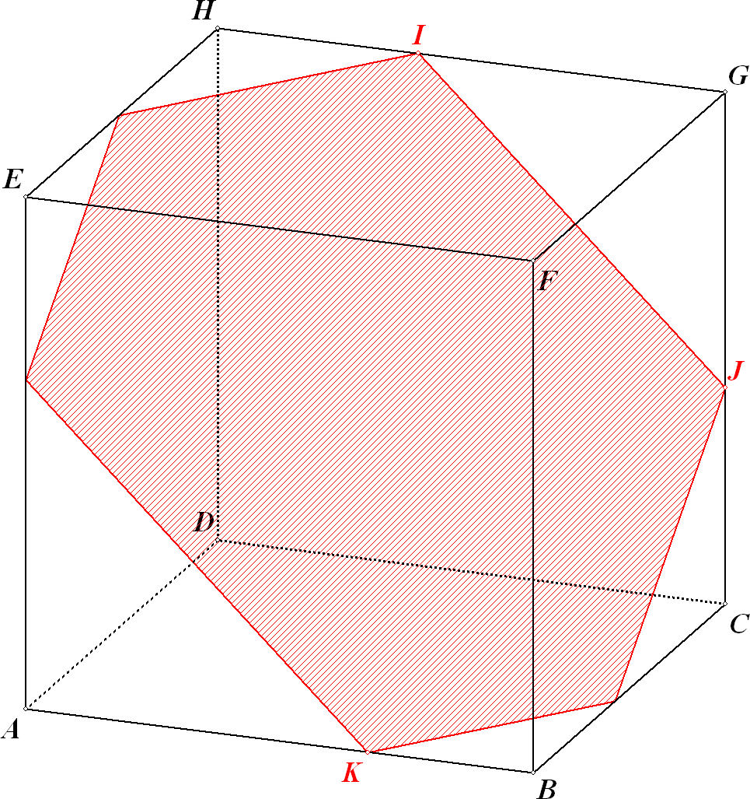
With the aid of this section you can perform several little investigations. For instance, you could drag and move one of the points I, J or K if you click the “drag button” . Or you could launch one of these points by clicking the button. And you could even launch several points at a time by pressing the button.

After pressing one of these buttons you can sit back and watch the section change but you could also right-click on the filled area which will bring up a menu that allows you to perform even more actions: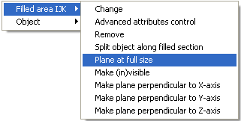

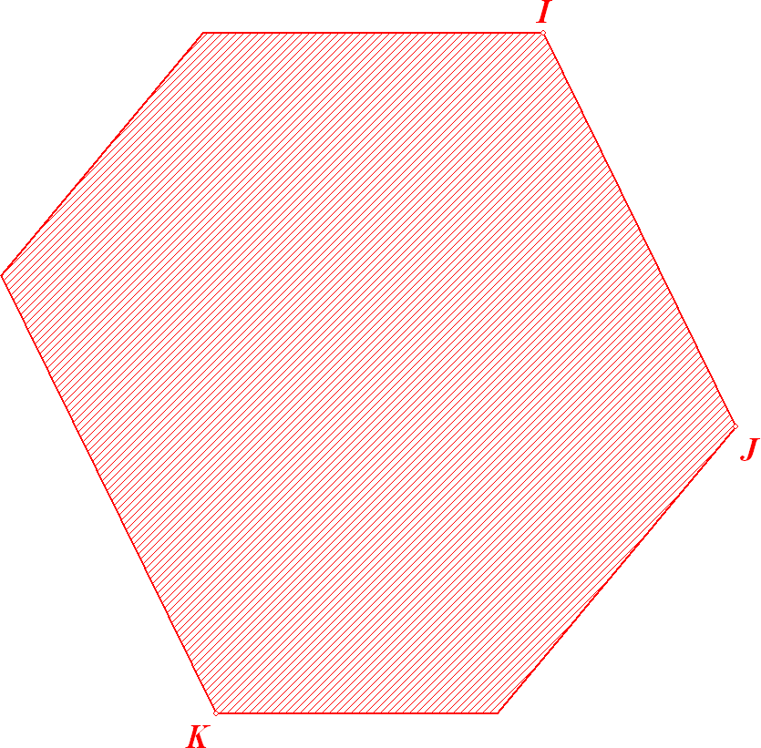
You can move the object in such a way that the plane is portrayed at full size which creates the possibility of treating the object as if it were part of plane geometry! After you have finished your investigation you can always return to the three-dimensional model.

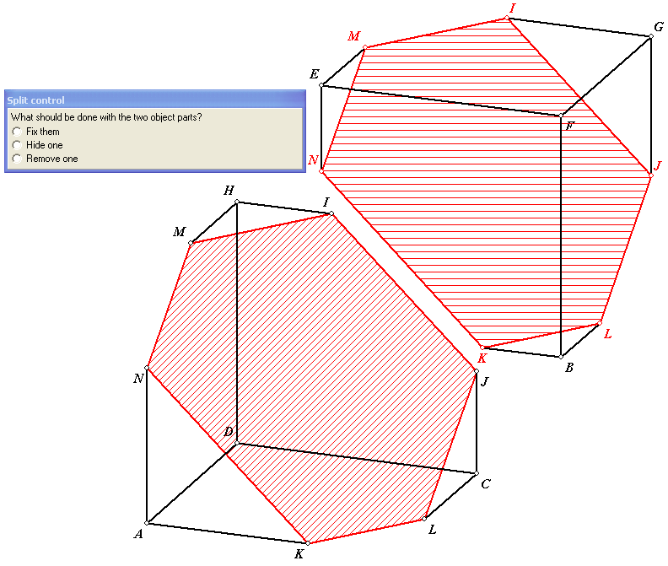
Another wonderful option is to split the object along the filled section. An animation will show the process and after its completion you will have the possibility of removing one of the two parts and continue your investigation with just one single part.

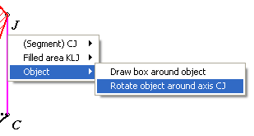
And if you are into rotations you can right-click on a line segment and rotate the object around the axis you just chose. The picture alongside shows the menu as it would appear should you click on line segment CJ in the drawing above.

Investigating a function

This exercise requires you to set the difficulty level to intermediate in the configuration window.
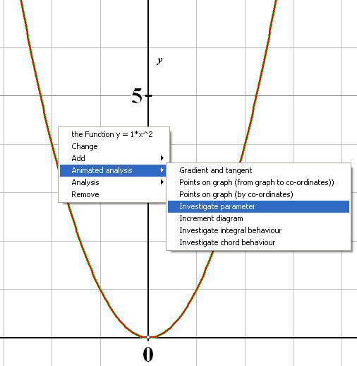
You should start with an existing drawing. Click file, open or click the open folder button . Open the “parabola with parameter” file, you will find it in the DEMO folder. The parabola y = x² will appear in the co-ordinate system.

Now, right-click this graph and a menu with one single line will appear. Click it and the menu will extend. You should choose the following: “animated analysis”, “investigate parameter”.

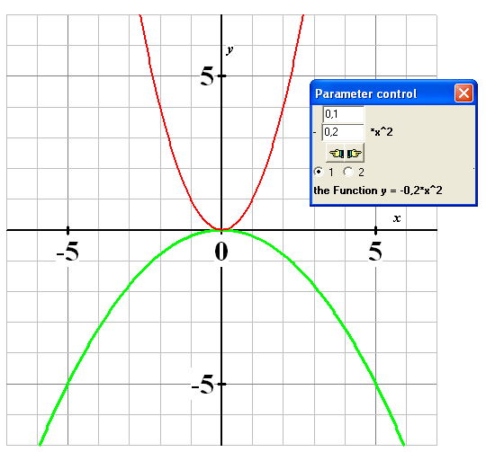
A (parameter) control box will pop up. The factor is listed before x and can be changed manually causing the parameter to change. (The number on the first line will either be added to or subtracted from the number on the second line. You can decide whether to increase or decrease the number.)

Changing the parameter will automatically and almost instantly result in a change in the drawing.

The bottom line of the control box displays the function formula as a whole once more.

In the drawing on the left, the parameter has been made negative. You can see how the original upward opening parabola changes to a downward opening parabola.

Two functions are now present and this is illustrated by the two radio buttons below the two little hands. You are now working on the first (green) function. Should you click on button number two, you will continue working with the second (red) function. You can now move it horizontally or vertically. The function is f (x) = (x – a)² + b and it contains two parameters. Geocadabra allows you to define functions yourself and these functions can consist of up to 4 parameters.

You can investigate even more functions. Why not explore the possibilities by right-clicking on one of the functions and scan the options in the presented menu?

Drawing in perspective

Geocadabra supports all drawing methods involved with three-dimensional objects:
- All parallel projections, just like you usually find them in books on mathematics;
- Central projection (= drawing in perspective), the same as when an object is photographed.

To give you somewhat of an idea about what drawing in perspective entails, we will use a pre-drawn, simple picture of a little house.

Start up Geocadabra and choose file, open.
Now open the demo folder and select the file that is titled house with windows and door. A small house, drawn in parallel perspective, will appear.
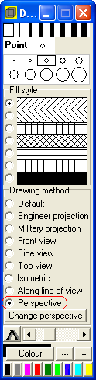
Click on the drawing method perspective in the toolbar. The house will now be drawn in perspective.
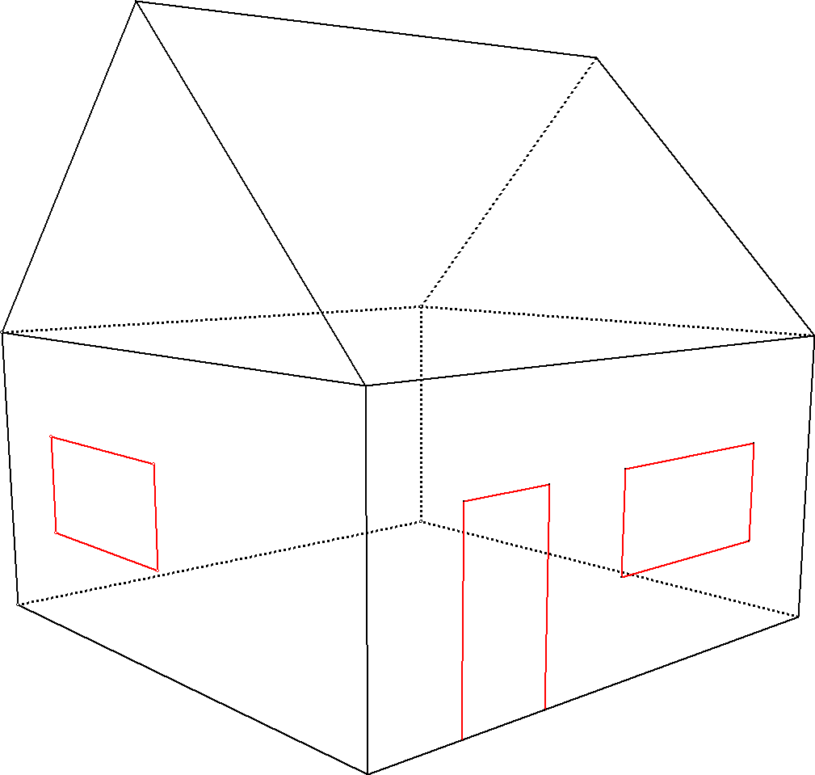
The demo version does not support all commands involved with drawing in perspective. For instance, the horizon and lines to vanishing points will not be shown. However, the following is possible:

Right-click on the button. You can now change the viewpoint by pressing the left mouse button and dragging the mouse into the desired direction. The drawing will move along with your mouse.

You can also right-click a line segment. A menu will appear allowing you to rotate the object around the axis you just selected. (See: Sections). You can now watch what happens when you rotate an object around one of its axis in perspective: when the house comes closer it will become bigger and vice versa, just like in the movies.

Experts only: if you left-click the button a screen will appear allowing you to control the camera position as well as the direction it is pointing in. The results of your adjustments will become visible instantly.

The CDROM features a complete course on perspective.
The contents of this course are based on the zebra booklet ‘Perspectief, hoe moet je dat zien’ by Agnes Verweij and Martin Kindt (Epsilon Uitgaven Utrecht, ISBN 90-5041-052-9). All notes and terms are directly taken from this booklet.

A probability tree

This exercise requires you to set the difficulty level to high (in the configuration window).

Geocadabra offers a few nice applications when it comes to probability. This demo allows for a limited probability tree to be drawn.

We are about to solve the following problem.

A vase is filled with 2 red and 8 blue balls.
After you have paid € 1,25 you are allowed to pick two balls in one go. Eyes closed of course!
You get paid €3 for every red ball and nothing for every blue ball you pick. Do you expect your chances of winning to increase or decrease depending on the number of turns?

Analysis of the model.

What we are dealing with is a draw without replacement from a vase containing 2 red and 8 blue balls.
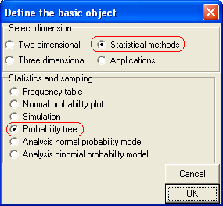
A probability tree will help us list all possible draws in one chart. By processing this probability tree and by determining the expected value of the turn out you get an impression of whether you will get paid more or less than your original stake.

A computation using Geocadabra.

We will start by selecting a new drawing. Choose statistical methods, probability tree and press [OK].

A probability tree box appears in which we can now select the data we want to use.
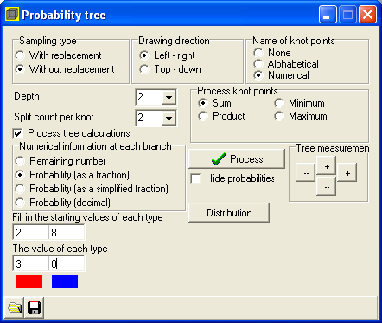
Mind the details:
- The sampling type should be without replacement
- Name of knot points: numerical. After all, we wish to calculate using amounts.
- Depth: 2;
We will take 2 balls from the vase
- Split count per knot: 2.
You can either pick a blue or a red ball so there are 2 possibilities per ball
- Process knot points: sum;
Every red ball is linked to € 3 and every blue ball to € 0 and it is these amounts you wish to calculate with.
- Numerical information at each branch: probability (as a fraction)
- Starting values of each type: 2 (red) and 8 (blue)
- Value of each type: € 3 for the red ball and € 0 for the blue ball
- You can click on the red or the blue square to select a colour. In this example the colours have already been set.
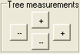
Now click the [process] button. The tree is drawn.
Sometimes the texts in the graph right from the tree are off screen. Click the buttons where it says “tree measurements” to adjust the size of the tree horizontally or vertically.
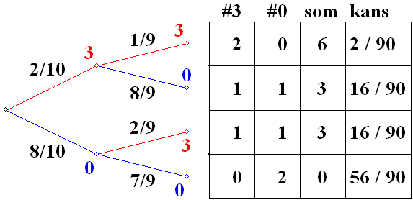
The tree will look like this:

If you were to, for example, follow the top branch you would get the following information:
The probability of getting two red balls equals . The sum of the total turnout (€ 3 per red ball) equals € 6.

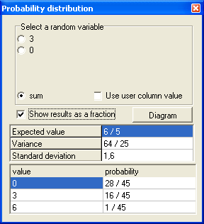
Now that the tree has been drawn and processed a new button has appeared.
Click it and a box will appear reading the continuation computations.
Now select:
- Variable: sum
After all, you would like to know the way the fraction functions
- Show results as a fraction: select
You would rather not deal with decimals.

The bottom three lines show the sum’s probability distributions. The bottom line tells you that the chance to receive a € 6 turnout equals . This is the of the probability tree.

The probability of receiving € 3 equals . This is the sum of the turnouts of the two branches that both generate € 3.

You can now start interpreting this probability distribution:
Out of every 45 times you enter the draw you will once receive € 6, 16 times €3 and 28 times you will receive nothing at all. This comes down to Euro a turn so that is an average of € 1,20.
Since you have to pay € 1,25 to enter the draw you will eventually loose € 0,05 every time you enter.

Epilogue

Geocadabra can calculate models of probability that can be simulated by means of a draw from a vase with or without replacement. The number of balls that can be drawn is adjustable and the same applies to individual colours. However, the maximum of adjustable colours is limited to 10. Instead of working with colours you can also work with related figures as is shown in the turnout above. It is also possible to work with variables (or stochastic models) per colour or you can work with the sum, the product or even with the maximum or minimum of the drawn numbers. You can save a model of probability to continue working on it at a later date.
The probability distribution screen has a button called
Pressing this will result in a histogram (= vertical bar graph) of the current probability distribution and this graph can then be further investigated. You can use a boxplot or you can use the normal distribution (including expected value and standard deviation both equal to those of the probability distribution). In return, you can use these to investigate whether a vase model more or less meets the characteristics of a normally distributed model. You can even have the probability distribution drawn out on regular probability plotting paper. According to the theory this should result in a straight line when using an exact normal model. You can now use the rules of thumb as they apply to a normally distributed model. Alongside is an impression of the model above but things do not start becoming truly interesting until you start with a model that has more depth (and colours).

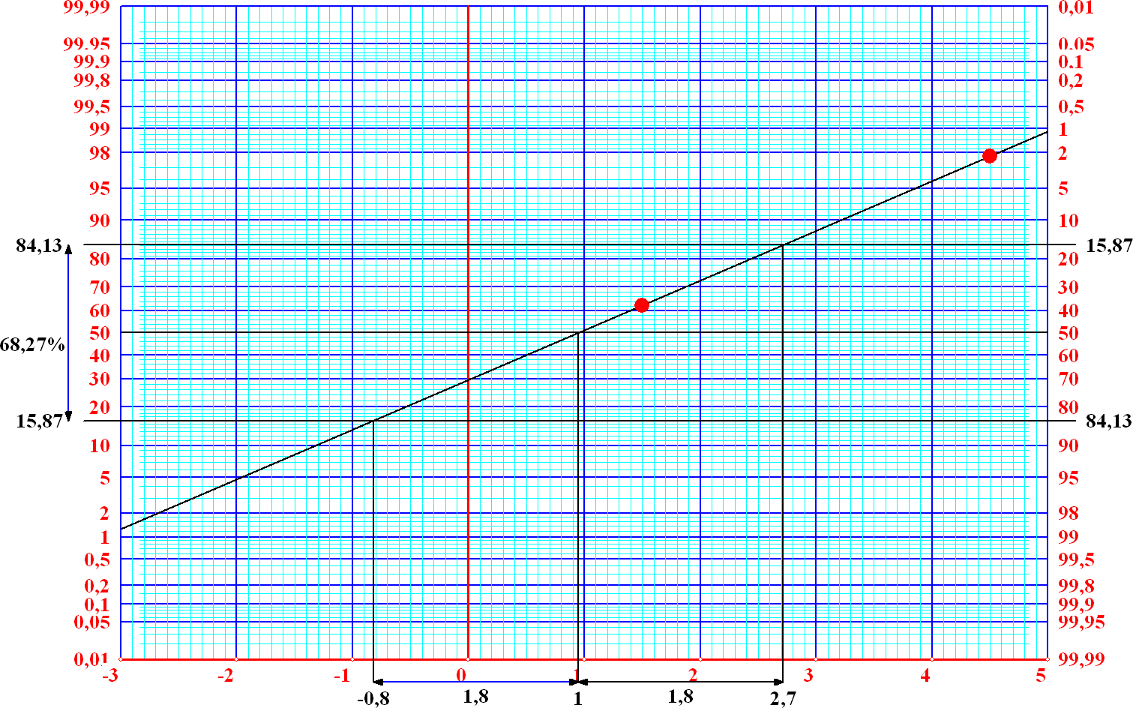
This programme will help you support a wonderful learning curve right to the final levels of secondary education.

The calculator

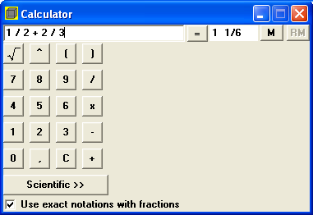
Geocadabra features a special calculator that can calculate using exact roots as well as fractions. Clicking on the calculator button will bring up the calculator. The calculator’s possibilities depend on the target group selected in the configuration box. We will start by giving you two examples with the difficulty set to low.

First example

Check the box below the buttons to activate the exact notations with fractions function. Please refer to the example alongside.
The configuration allows you to adjust the representation of the fractions. The outcome of this particular example is 1 1/6 but the answer can also be 7/6

Second example

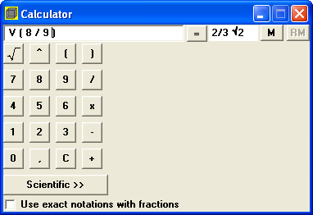
Select show root numbers if possible in the show numbers part of the configuration box.
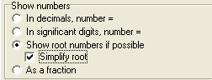
The capital V should be regarded as the root symbol.
Alongside √ 8/9 has been reduced to 2/3 √2.

Third example

Using the calculator with difficulty set to high.
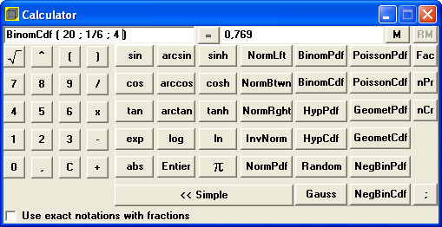
Below you find the answer to the following question: In a dice game you are allowed to throw the dice twenty times. How likely are you to throw a maximum of 4 sixes?

When you hover your cursor over a key, a syntax explaining the function of that particular key will appear.

Getting a taste of the licensed version

Some menus are not available in the demo version:
- Maintenance
- (Geometrical) transformations
- Calculations

The maintenance menu is the heart of the programme and in it you will find all commands needed to add vertices, lines, vectors, functions, conic sections, areas and shadings to a figure. This menu also provides you with interesting applications such as the possibility to construct a net of a three-dimensional model. This way you can create a cutout.
Transformations are: rotations, point and line reflections, translations, point multiplications and enlargement or reducibility.
Apart from providing the drawing with an angle, length or distance, the calculations also give it a supporting construction.

In order to view some of the menu’s possibilities we will use the quick search bar in the top centre of the screen.
The first ten keys are user-defined. You can assign much used commands to them so you will not have to go out of your way to find them in sub-sub-menus.

The keys have been assigned the following functions in the demo version:

1: Click on line (segment) to place a point on it
2: Click on 2 points and the centre will be determined
3: Add a point by entering the co-ordinates
4: Click on 2 points and the line segment in between them will be drawn
5: Click on 3 points and a circle will be drawn connecting all 3 points
6: Click on 3 points and the plane connecting them will be lifted up from the drawing and shown at full size
7: Click somewhere on the screen to place a text
8: A wire model will be drawn around the object with box edges // co-ordinate system
9: Click on 3 points and (the altitude) the altitude point of the triangle will be drawn
10: Click on 3 points and (the median and the central point will be drawn
[ ]: Click on 3 points to draw the section of the object as well as the plane through these 3 points

Keys 6, 8 and 10 are designed to function with respect to three-dimensional figures but the other keys can be used with both plane as well as three-dimensional figures.
When working on a drawing, you can, after you have pressed a key, read the instructions in the status line below the drawing.

Why not start with a cube and draw in some points, line segments, some shading and a circle?

Have fun!

