Alternative tetrahedron puzzle

There are several ways to divide a tetrahedron into some pieces, to make a puzzle.
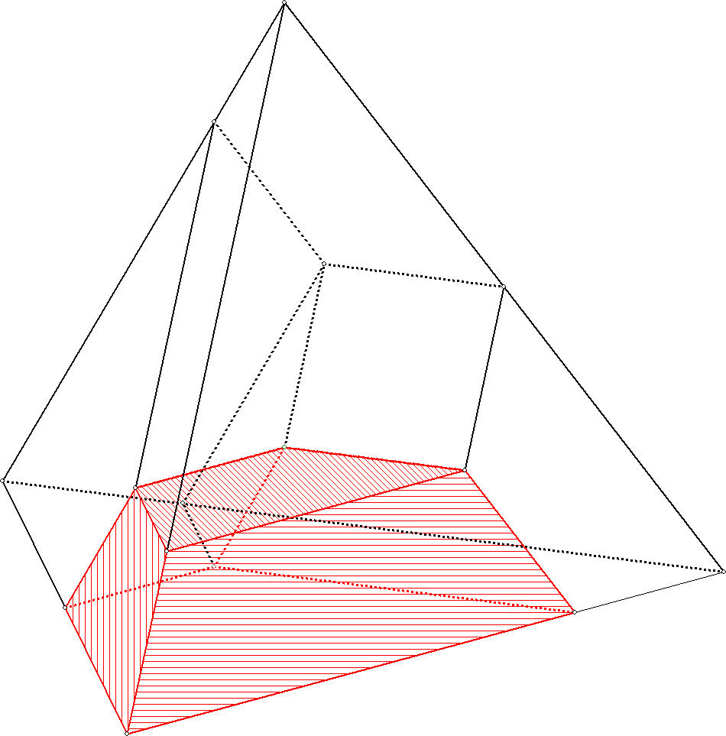
But to do it in a way that all pieces are the same, is difficult.
In this document we will divide the tetrahedron into four equal pieces in an surprising way.

In the picture the tetrahedron is divided into 4 congruent pieces. But the picture is not clear for everyone.
One of the pieces is marked in red.
Geocadabra is able to form this red piece by cutting all other parts off, and make a net of th remaining piece.
On the next page this net is drawn.
Just print this net four times on thick paper, cut it out, fold it and glue the flaps, and your puzzle is ready!
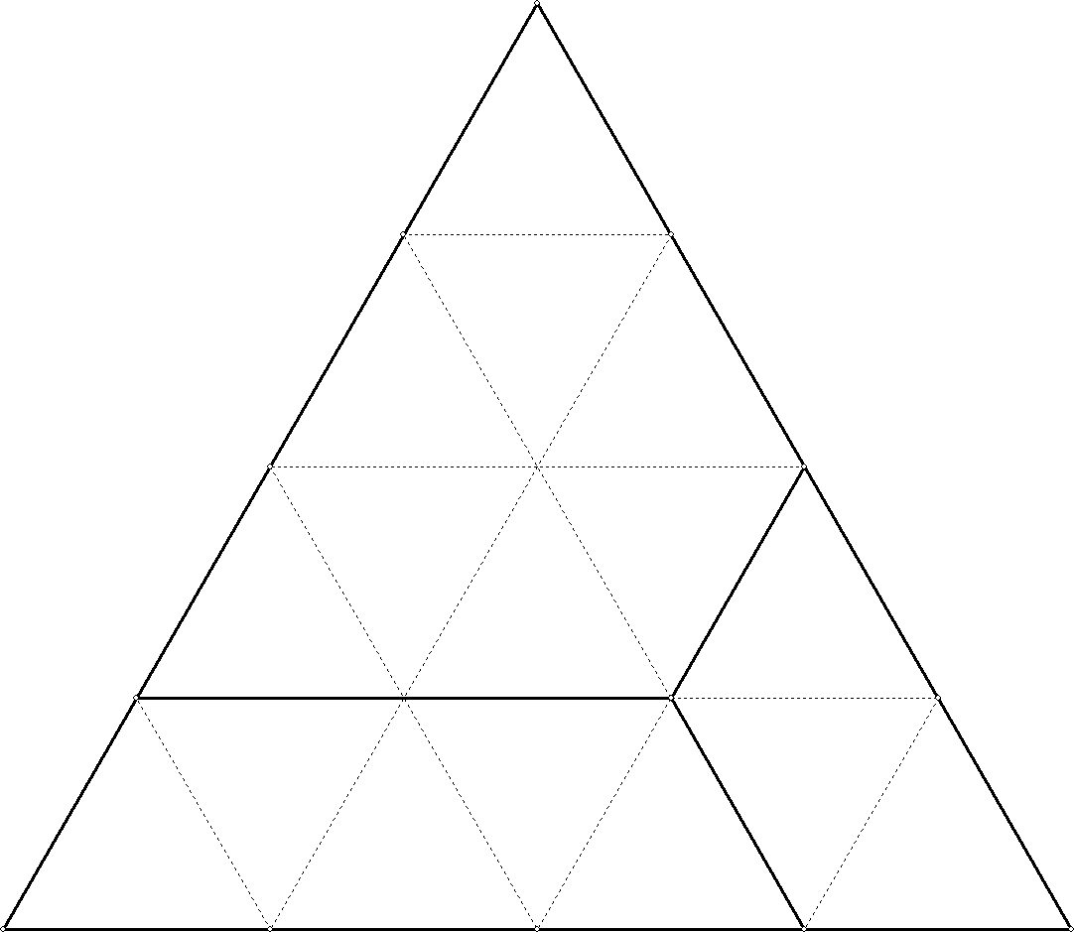
Here you see how is one of the sides of the tetrahedron divided to get this result:

